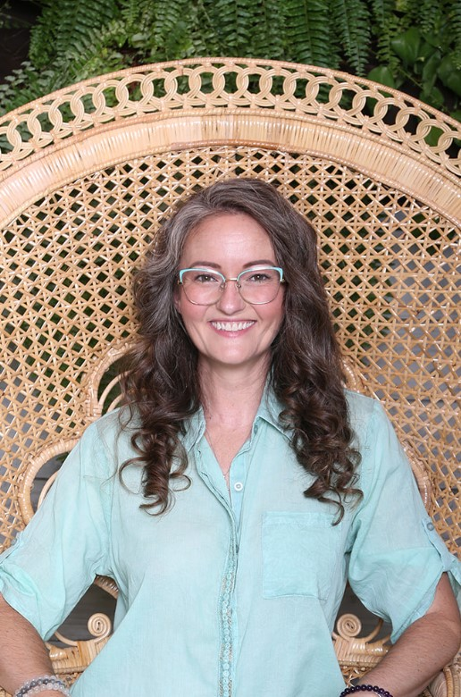
Welcome, Shamanic Energy Practitioner, Bree Kasper to Northern Nevada Healing Arts of Reno, Nevada. A Nevada native, Bree has walked the shamanic path of timelessness since childhood. Compounded with years of spiritual experiences as well as formal training with The Four Wind’s shamanic teacher and medical anthropologist Dr. Alberto Villoldo. Bree’s initation with the medicine wheel and ancestors has awoken shamanic sight and intentionality which she shares readily in session. Bree helps clients find their sacred sychronicity to the greater whole, feel lighter, find peace, release trauma, disengage blocking frequencies, and remove stale qi (chi).
Bree’s passion and connection to nature extends to her green thumb as well. She plants, nurtures, growths and harvests orangic herbal plants that she then converts to medicinal teas, tinctures, topicals and more. Her herbal tea blends, called Gaia’s Custom Tea Blends by Bree can be found in the waiting room.
Nature nurtures nournishment, come explore how the nautral world supports growth, well being and development, book your shamanic healing session today.

